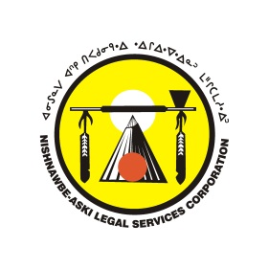
Community Youth Intervention Program Community Referral
Intake Form

Date: __________________________________
Client Name: _______________________________________________________________
D.O.B ___________________________ Gender Male / Female
Address: _______________________________ First Nation:______________________
_______________________________________
Parent / Guardians ________________________ Telephone #_______________________
Referrer _________________________________

The Youth Intervention Program is looking to enhance services and recruit youth for community activities; this does not mean that the youth are in conflict with the law in any way. By signing this referral form, the parent or guardian agrees that the youth can participate in community service, traditional activities, rabbit snaring, and will allow the youth worker to take them out of the school for an afternoon without being marked absent.
All safety measures will be taken while on an event, therefore any injuries or loss of property will not be the responsibility of Nishnawbe-Aski Legal Services or the Youth Intervention Worker.

Parent/ Guardian Name: __________________________
Signature: _______________________
YIW: __________________________ Signature: ________________________

