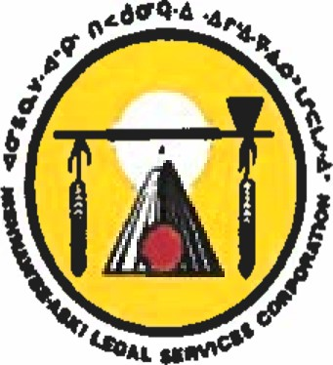
Employment Opportunity
Nishnawbe-Aski Legal Services Corporation
Community Legal Worker
Pikangikum, Ontario

(6) Month Contract
The Nishnawbe-Aski Legal Services Corporation provides legal, paralegal, and law-related services, public legal education, research, and law reform services to the members of the First Nations of Nishnawbe-Aski Nation (NAN). The Corporation also functions as an Area Office of Legal Aid Ontario (LAO).
The Nishnawbe-Aski Legal Services Corporation is presently recruiting (1) 6-month contract position (with the possibility for an extension) for Community Legal Worker for Pikangikum, Ontario.
The CLW is a crucial member of the NALSC team. She/He will work with justice personnel and the community to improve the administration of the Euro-Canadian legal system of justice, and assist clients and their families in various legal matters. S/he will play a central role in the development and delivery of public legal education in the communities and assist in the promotion and implementation of NALSC restorative justice programs.
Qualifications:
successful completion of Secondary School at a minimum, but some post-secondary education is preferred; knowledge of the Euro-Canadian legal system and knowledge of Restorative Justice alternatives; experience in organizing and delivering programs must be discreet and professional; able to work with minimal supervision excellent written and oral communications skills ability to speak the Ojibway language fluently is a definite asset; willingness to communicate with others about law-related and traditional issues; must be willing and able to travel and must have access to reliable transportation
Location: Pikangikum, Ontario
Salary: Salary to commensurate with experience
Closing Date: August 23, 2019
Please submit your resume and cover letter including 3 references to:

Nishnawbe-Aski Legal Services Corporation
1805 East Arthur St.,
Thunder Bay, ON, P7E 2R6
Fax: 1-807-622-1413 Email: hr@nanlegal.on.ca

